Name: DEVARAJU SAITULSIRAM
Enrollment No: 2403A510E8
SCHOOL OF COMPUTER SCIENCE AND ARTIFICIAL INTELLIGENCE |  |  |  |  | DEPARTMENT OF COMPUTER SCIENCE ENGINEERING
Program Name: B. Tech |  |  |  | Assignment Type: Lab |  |  | Academic Year:2025-2026
Course Coordinator Name |  |  |  | Venkataramana Veeramsetty
Instructor(s) Name |  |  |  | Dr. V. Venkataramana (Co-ordinator)  Dr. T. Sampath Kumar  Dr. Pramoda Patro  Dr. Brij Kishor Tiwari  Dr.J.Ravichander  Dr. Mohammand Ali Shaik  Dr. Anirodh Kumar  Mr. S.Naresh Kumar  Dr. RAJESH VELPULA  Mr. Kundhan Kumar  Ms. Ch.Rajitha  Mr. M Prakash  Mr. B.Raju  Intern 1 (Dharma teja)  Intern 2 (Sai Prasad)  Intern 3 (Sowmya)  NS_2 ( Mounika)
Course Code |  |  | 24CS002PC215 | Course Title |  | AI Assisted Coding
Year/Sem |  |  | II/I | Regulation |  | R24
Date and Day  of Assignment |  |  | Week5 - Monday | Time(s)
Duration |  |  | 2 Hours | Applicable to  Batches
AssignmentNumber: 9.1(Present assignment number)/24(Total number of assignments)
 | Q.No. | Question |  |  |  |  |  | Expected Time  to complete
 | 1 | Lab 9 – Code Review and Quality: Using AI to improve code quality and readability  Lab Objectives  - Inline comments  - Docstrings  - Auto-documentation tools  - AI-assisted summarization  Task Description #1 (AI-Assisted Bug Detection)  Scenario: A junior developer wrote the following Python function to calculate factorials:  def factorial(n):  result = 1  for i in range(1, n):  result = result * i  return result  - Run the code and test it with factorial(5)  (expected output = 120).  - Use AI (prompting) to review this code and identify the bug.  - Ask AI to suggest corrections and rewrite the code.  - Compare AI’s corrected code with your own fix.  Prompt: Identify the error in the code.  Code:  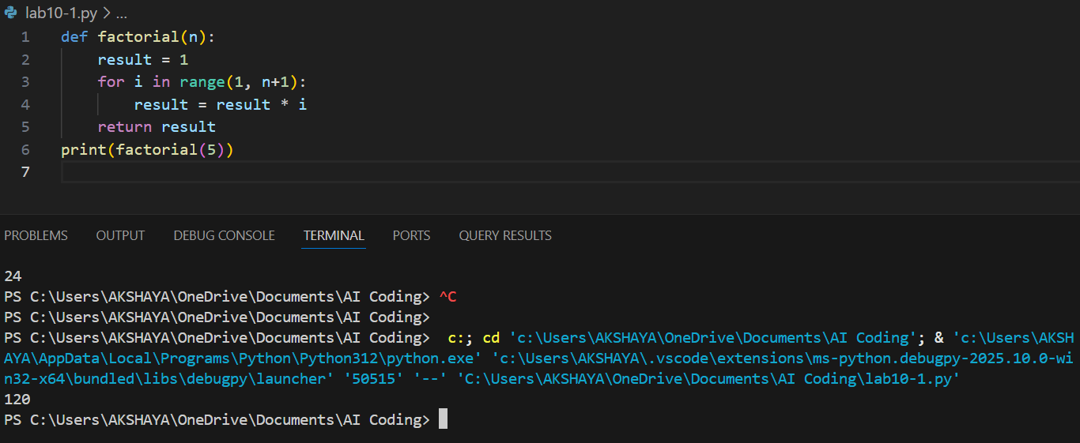  Observation: The code underestimates factorial results because the loop iterates from 1 to n-1, omitting the last number n, which leads to an incomplete multiplication sequence.  Task Description #2 (Improving Readability & Documentation)  Scenario: The following code works but is poorly written:  def calc(a,b,c):  if c=="add":  return a+b  elif c=="sub":  return a-b  elif c=="mul":  return a*b  elif c=="div":  return a/b  - Use AI to review this code for readability, naming, and documentation issues.  - Prompt AI to rewrite the code with:  - Clear function & variable names.  - Proper docstrings.  - Exception handling for division by zero.  - Compare the before-and-after versions to evaluate AI’s contribution.  Prompt: Rewrite the code with clear function & variable names, proper docstrings and exception handling for division by zero.  Code:  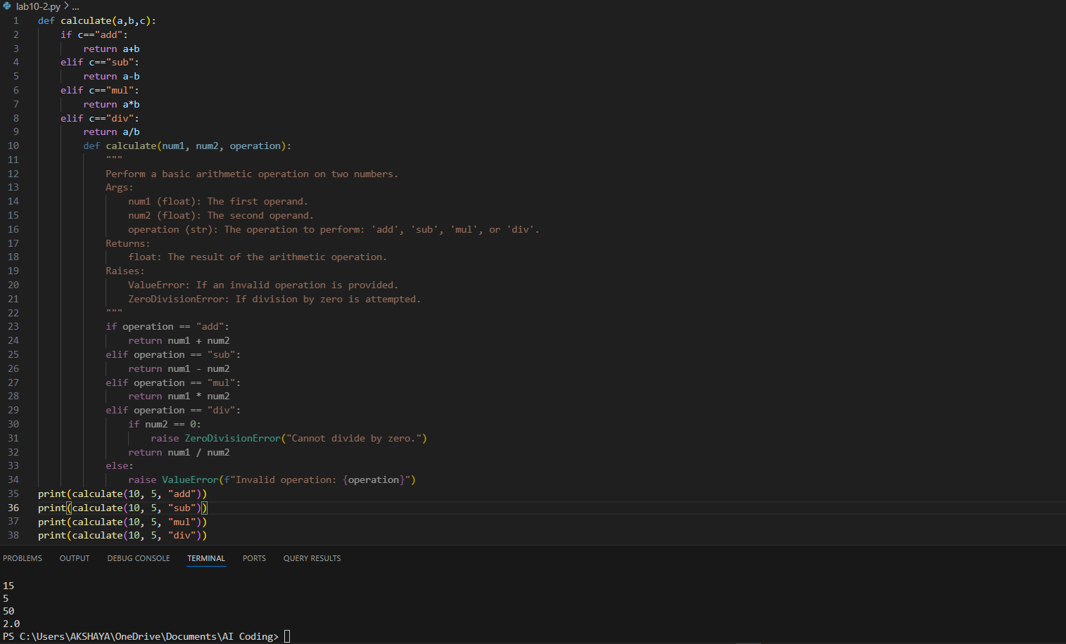  Observation: The calculator function works correctly but lacks readability and maintainability. Non-descriptive names like calc, a, b, and c, along with missing docstrings, make it difficult to understand. Moreover, division by zero is not handled, which could cause runtime errors. After AI-assisted improvements, the code now includes meaningful names, clear documentation, and exception handling, resulting in a cleaner, more robust, and user-friendly implementation.  Task Description #3 (Enforcing Coding Standards)  Scenario: A team project requires following PEP8 style guide. One developer submits:  def Checkprime(n):  for i in range(2,n):  if n%i==0:  return False  return True  - Run this code and verify correctness.  - Use AI to perform a code quality review for PEP8 compliance.  - Prompt AI to return a re-factored version with proper indentation, spacing, and naming conventions.  - Discuss how automated AI review can save time in large-scale projects.  Prompt: Return the code with a re-factored version with proper,spacing, and naming conventions.  Code:  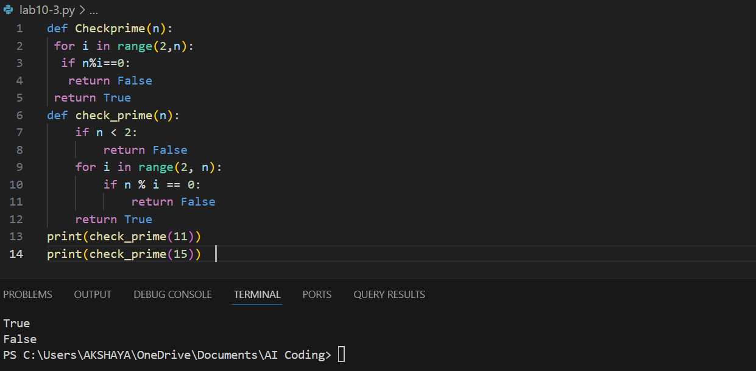  Observation: The submitted program correctly determines prime numbers, but it does not adhere to PEP8 style standards for function names, indentation, and spacing. The function name Checkprime should follow snake_case (check_prime), and consistent indentation and spacing should be applied to enhance clarity. After refactoring, the code is more readable, organized, and aligned with Python’s styling guidelines. Automated AI review accelerates identification of such issues, ensuring consistency, minimizing manual effort, and improving overall code quality in large projects.  Task Description #4 (AI as a Code Reviewer in Real Projects)  Scenario: You are part of a GitHub project. A teammate submits this pull request:  def processData(d):  return [x*2 for x in d if x%2==0]  - Review this function manually for readability, reusability, and edge cases.  - Use AI to generate a code review comment, focusing on:  - Naming conventions.  - Input validation (e.g., what if d is not a list?).  - Adding type hints.  - Modify the function based on AI’s suggestions.  Prompt: Generate a code review comment, focusing on: Naming conventions, input validation (e.g., what if d is not a list?), adding type hints.  Code:  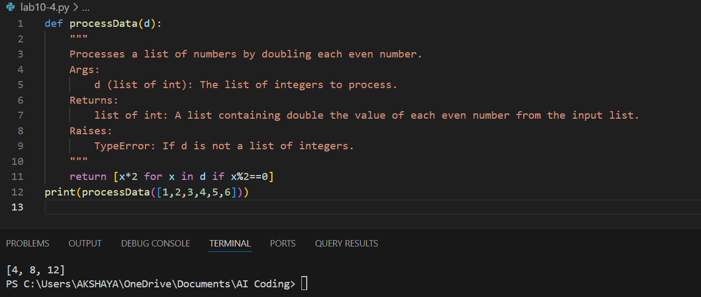  Observation: The submitted function works correctly for doubling even numbers but lacks adherence to best practices. The function name processData should follow snake_case (process_data) for consistency with PEP8 naming conventions. Input validation is important to handle cases where the argument is not a list of integers, and adding type hints improves code clarity. The refactored version with proper docstrings, type hints, and error handling enhances readability, reusability, and robustness. Automated AI review helps in identifying such improvements quickly, ensuring higher quality and maintainable code in collaborative projects.  - Write a short reflection: Would you trust AI as a standalone reviewer, or only as a support tool? Why? |  |  |  |  |  | Week5 - Monday

